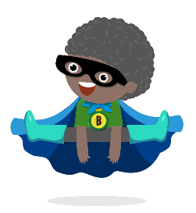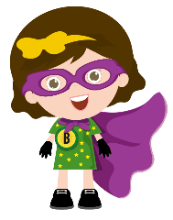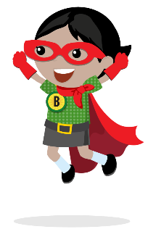

* I will not share my equipment, on my desk, with other children in my group.
* I will wash my hands frequently throughout the day, for at least 20 seconds, and especially after sneezing or coughing.
* I will tell an adult in school if I feel unwell at any point throughout the day.
* I will play in the designated zone my teacher has created for my group to play in whilst outside.
* I will try and keep my hands to myself as best I can and refrain from physical contact with my friends.
* I will listen to my teacher and follow instructions.
* I will start my day on **green** and aim to end the day on **green** too.
* I will stick to the rules of **Catch it, Bin it, Kill it** when using a tissue.
* I will move around school when my teacher tells me it is safe to do so.
* I will only use the toilet when my teacher tells me it is safe to do so.

**Code of Conduct**